**LAB5: Context Free Language  
 –Siddharth Karmokar, 123CS0061**

Lex:

%{

#include "lab5b.tab.h"

#include "lab5c.tab.h"

#include "lab5d.tab.h"

#include "lab5e.tab.h"

#include<stdio.h>

%}

%%

[ \t]+ ; /\* Ignore spaces and tabs \*/

"\n" { return NL; }

"a" {return ZERO;}

"b" {return ONE;}

. {/\* Ignores unrecognized characters \*/}

%%

int yywrap(){

return 1;

}

yacc 1:

%{

#include<stdio.h>

#include<stdlib.h>

int yylex();

void yyerror(const char\* s);

%}

%token ZERO ONE NL

%%

s1: s2 n1{};

s2: ZERO s2 ONE {}

| ZERO ONE {}

;

n1: NL {return 0;}

%%

int flag;

int main(){

flag = 0;

printf("Enter the expression(in a and b)\n");

yyparse();

if(flag == 0){

printf("Expression is a valid a^nb^n\n");

}

return 0;

}

void yyerror(const char\* s){

fprintf(stderr, "Expression is not a valid a^nb^n\n");

flag = 1;

}

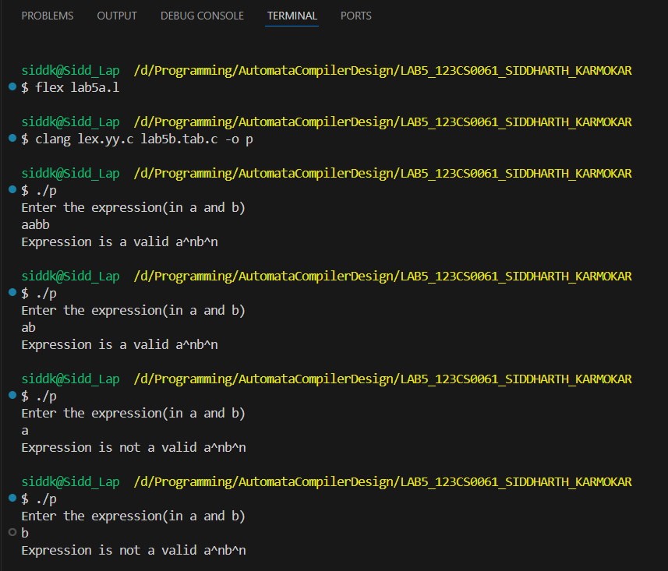

yacc 2:

%{

#include<stdio.h>

#include<stdlib.h>

int yylex();

void yyerror(const char\* s);

%}

%token ZERO ONE NL

%%

s1: s2 n1{};

s2:ZERO ONE

| ZERO ONE s2

;

n1: NL {return 0;}

%%

int flag;

int main(){

flag = 1;

printf("Enter the Expression(in a and b)\n");

yyparse();

if(flag == 1){

printf("Expression is a valid (ab)^n\n");

}

return 0;

}

void yyerror(const char\* s){

fprintf(stderr, "Expression is not a valid (ab)^n\n");

flag = 0;

}

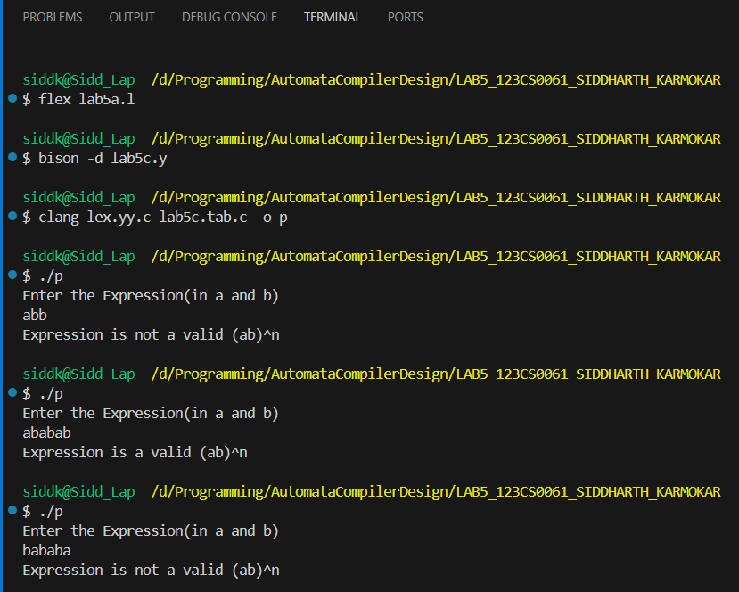

yacc 3:

%{

#include<stdio.h>

#include<stdlib.h>

int yylex();

void yyerror(const char\* s);

%}

%token ZERO ONE NL

%%

s1: s2 n1{};

s2: ZERO s2 ONE ONE{}

| ZERO ONE ONE{}

;

n1: NL {return 0;}

%%

int flag;

int main(){

flag = 0;

printf("Enter the expression(in a and b)\n");

yyparse();

if(flag == 0){

printf("Expression is a valid a^nb^2n\n");

}

return 0;

}

void yyerror(const char\* s){

fprintf(stderr, "Expression is not a valid a^nb^2n\n");

flag = 1;

}

